**MESD LMS Documentation – View/print/download Staff profiling**

To facilitate with viewing/printing/downloading staff profiles.

**Background**

This module handles requests directly from the School Head to view staff profiles.

**Usage**

**Adding the block**

1. Log in as the School Head.
2. Turn on edit mode at the top right corner of your screen.
3. Go to your *‘Dashboard’*.
4. Open the block drawer then under *‘Add a block’* click on the *‘Add’* dropdown and, find and select the *‘Search User’* option to add the block.

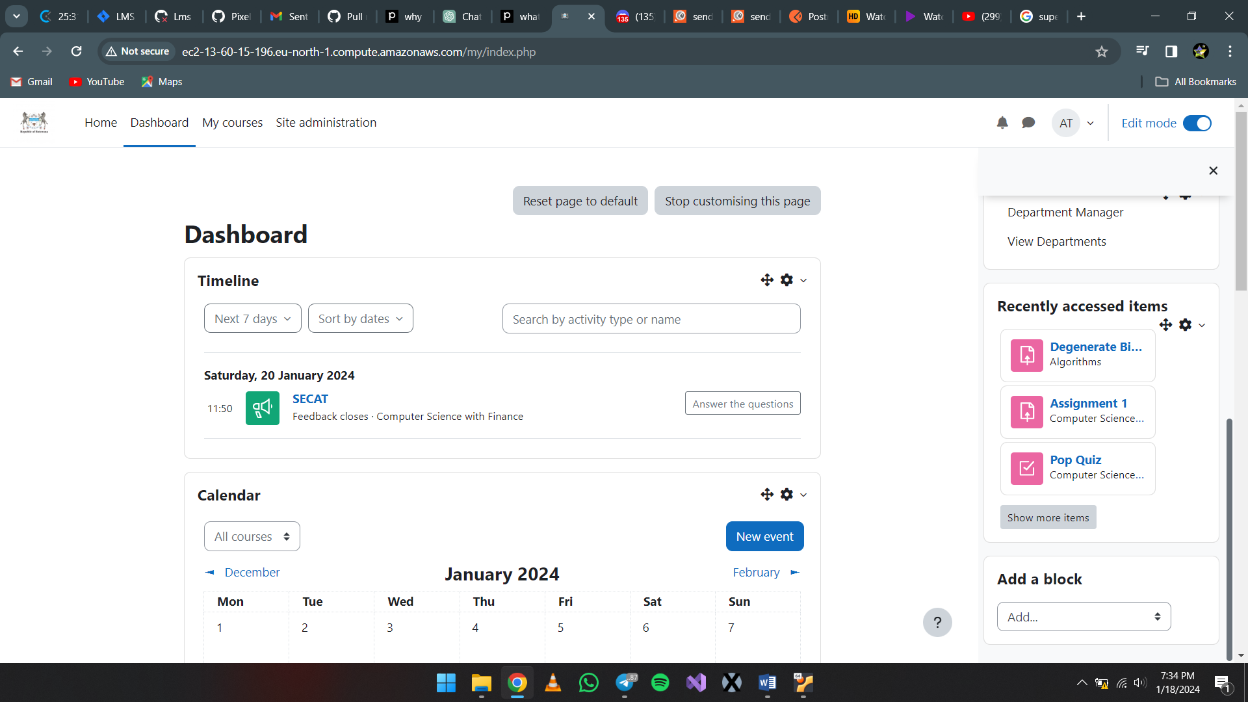

**View staff profiles**

1. Login as the School Head.
2. Go to *‘Dashboard’*. Open the block drawer on the right side of the screen and find the *‘Search Users’* block.
3. Use the search bar to look for the specific staff member. (Search by their full name or email)
4. Select the staff member and click on *‘Go to profile’*.

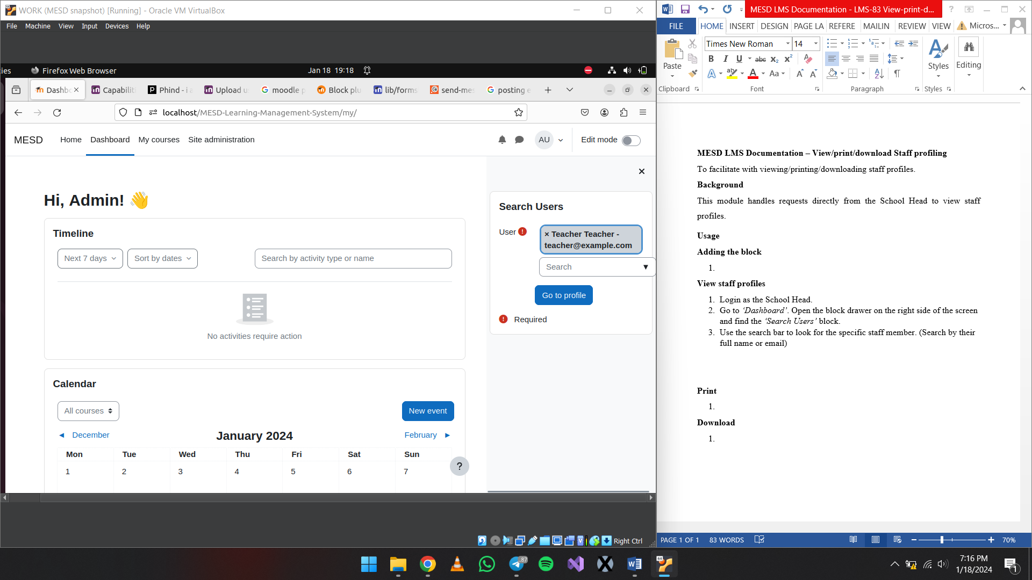

1. Step 4 will then take you to the staff’s moodle profile.

**Print/Download**

1. Log in the School Head then follow the **View staff profiles** instructions above.
2. While on the view profile page, on your keyboard press CTRL + P to progress to printing the profile.
3. Depending on your browser you will get a prompt on how to print along with other options. Make sure you are connected to your printer and select *‘Print’*.

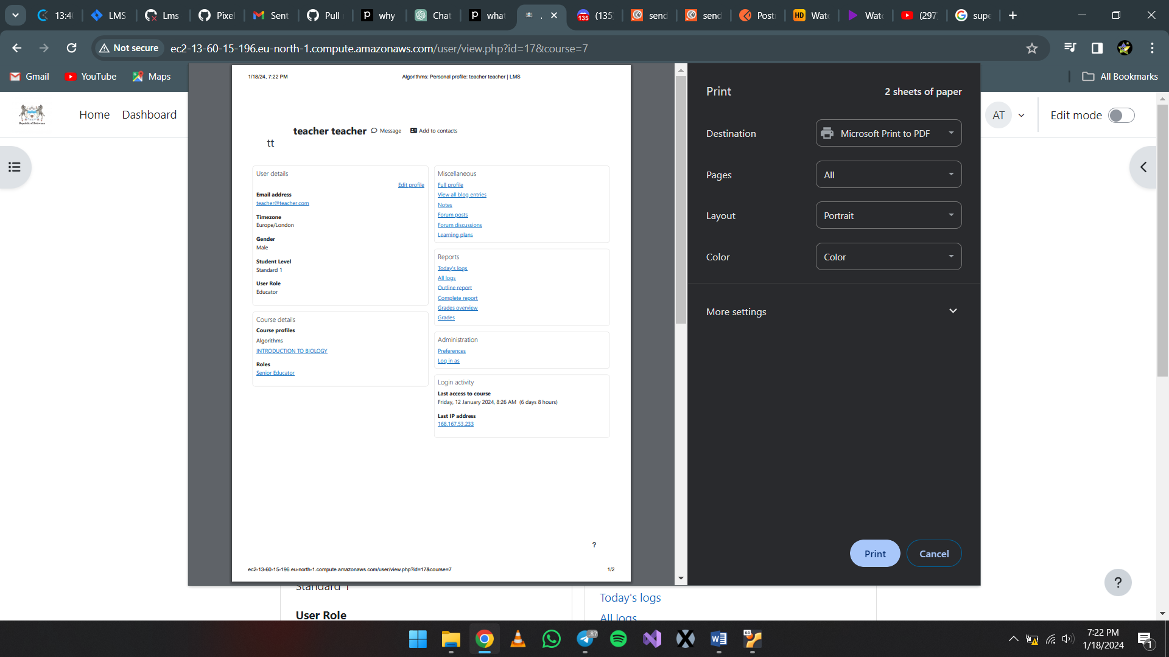

1. Depending on your OS and browser, using CTRL + P also allows you to save/download the profile as a pdf.

**DEVELOPER INFORMATION**

Capabilities

block/search_user:usesearchuser : Allows the user to use the block.